Create a transaction line field to source location information and paste it into the lines of the cart:
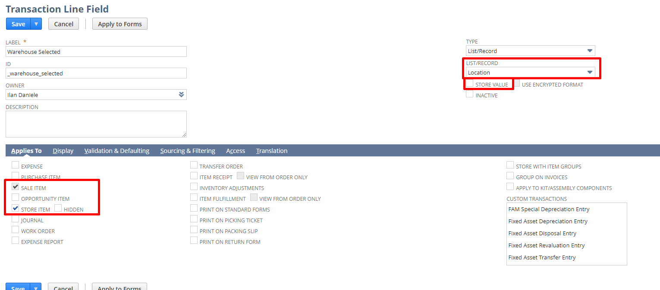
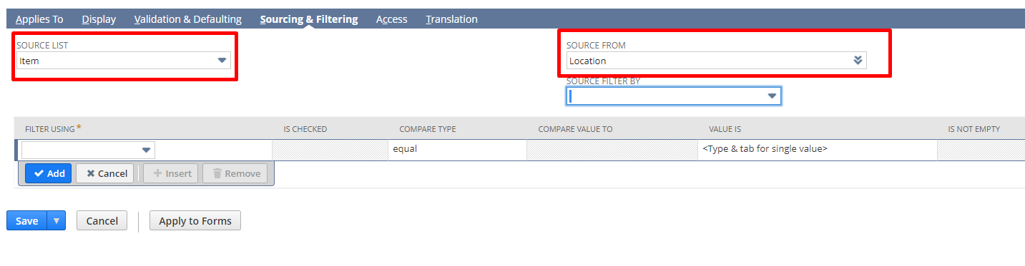
Save.
In commerce -> Websites -> Configuration: pick site
Advanced -> Backend
Add custcol_warehouse_selected (which I had created) to shopping’s order items and checkout’s order item:
